Project Design Phase-II
Technology Stack (Architecture & Stack)

Date | 6 February 2026
Team ID | LTVIP2026TMIDS24589
Project Name | Plugging into the Future: An Exploration of  Electricity Consumption Patterns Using Tableau
Maximum Marks | 4 Marks

Technical Architecture:
The Deliverable shall include the architectural diagram as below and the information as per the table1 & table 2
Example: Order processing during pandemics for offline mode
Reference: https://developer.ibm.com/patterns/ai-powered-backend-system-for-order-processing-during-pandemics/
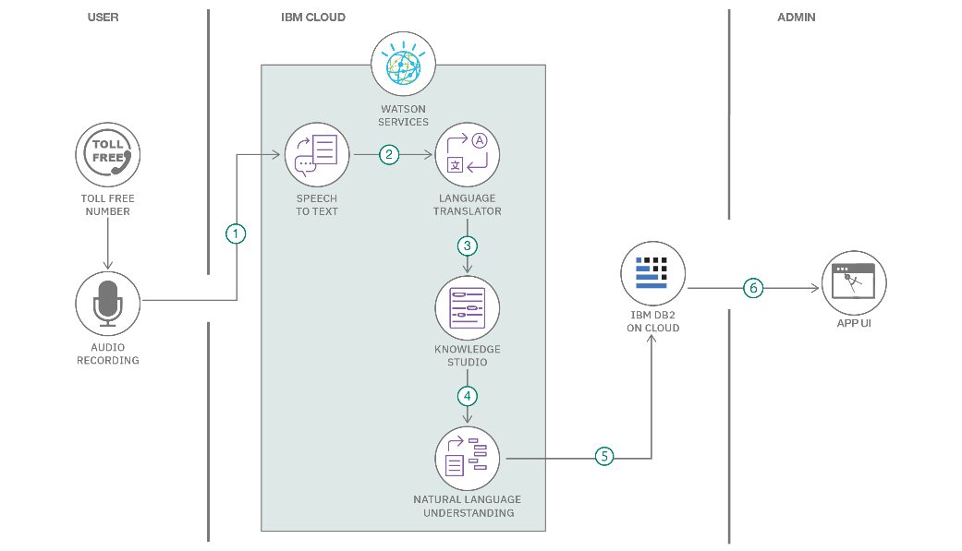
Table
-
1

:
Components

&

Technologies:

Table
-
2:

Application

Characteristics:

References:

Guidelines:

Include

all

the

processes

(
As

an

application

logic

/
Technology Block)

Provide

infrastructural

demarcation

(
Local

/

Cloud)
Indicate external interfaces (third party API’s etc.)
Indicate Data Storage components / services
Indicate interface to machine learning models (if
applicable)

S.No | Component | Description | Technology
1 | User Interface | Dashboard interface for viewing electricity consumption trends | Tableau Public
2 | Application Logic-1 | Script for data cleaning and formatting | Python (Pandas, NumPy)
3 | Application Logic-2 | Data reshaping and exporting for Tableau | Python
4 | Database | Processed CSV/Excel  files | Local Filesystem
5 | Cloud Database | N/A – Static files used in Tableau | N/A
6 | File Storage | Stores preprocessed datasets | Local Storage
7 | External API-1 | Open energy datasets | data.gov.in, Kaggle
8 | External API-2 | Weather correlation data (optional) | OpenWeather API
9 | Machine Learning Model | Optional forecasting model (future scope) | Prophet / Scikit-learn
10 | Infrastructure | Application setup and dashboard hosting | Local preprocessing + Tableau Cloud

S.No | Characteristics | Description / Technology
1 | Open-Source Frameworks | Python (Pandas, NumPy), Tableau Public
2 | Security Implementations | Tableau’s built-in access control and published link privacy
3 | Scalable Architecture | Scalable via Tableau’s support for large datasets and filters
4 | Availability | High availability via Tableau Public’s cloud-hosted platform
5 | Performance | Fast rendering through preprocessed and optimized data, cache-enabled dashboards

https://c4model.com/
https://developer.ibm.com/patterns/online-order-processing-system-during-pandemic/ https://www.ibm.com/cloud/architecture https://aws.amazon.com/architecture
https://medium.com/the-internal-startup/how-to-draw-useful-technical-architecture-diagrams-2d20c9fda90d

